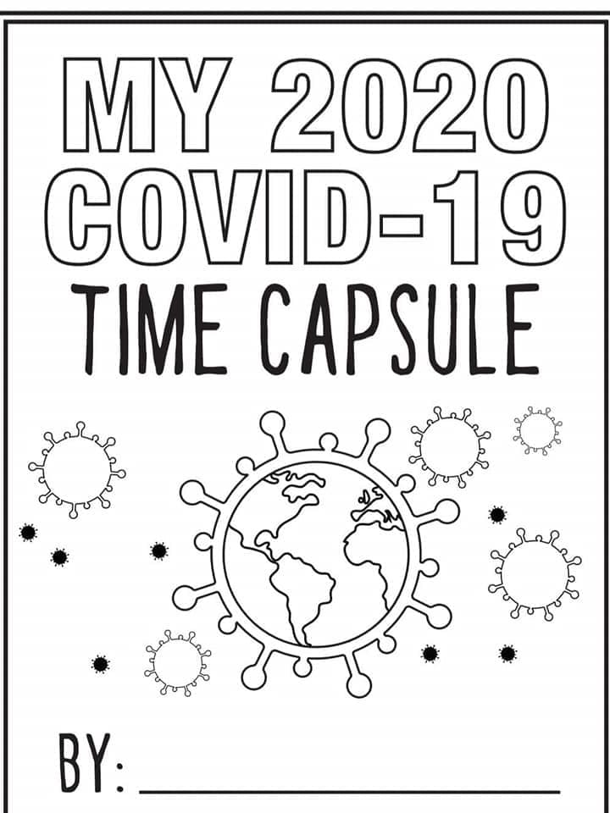
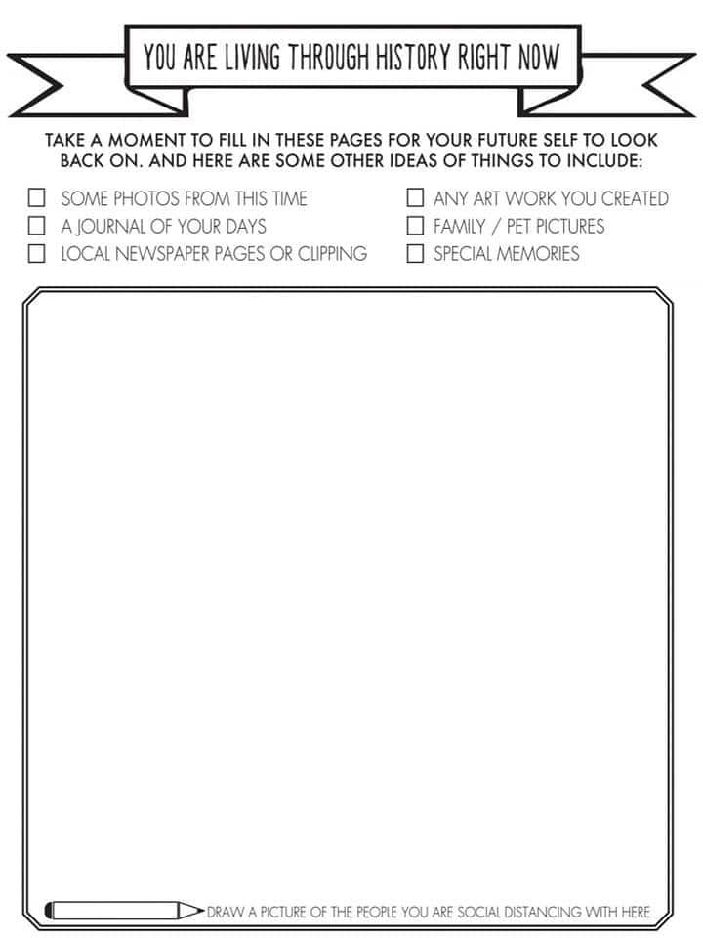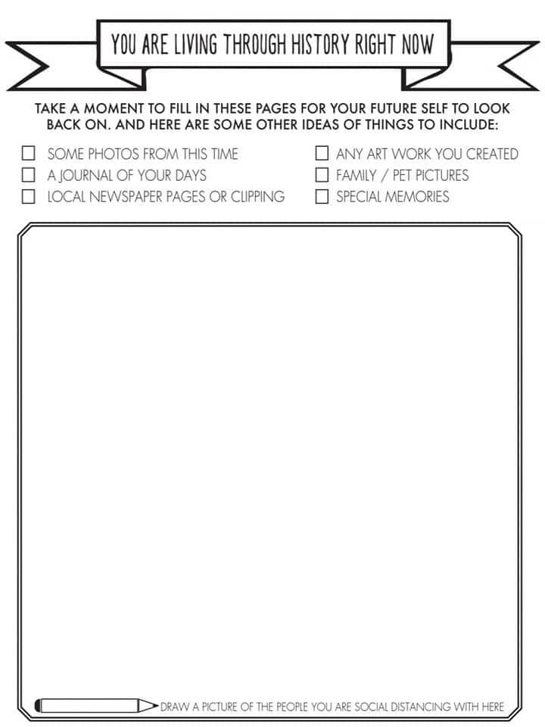

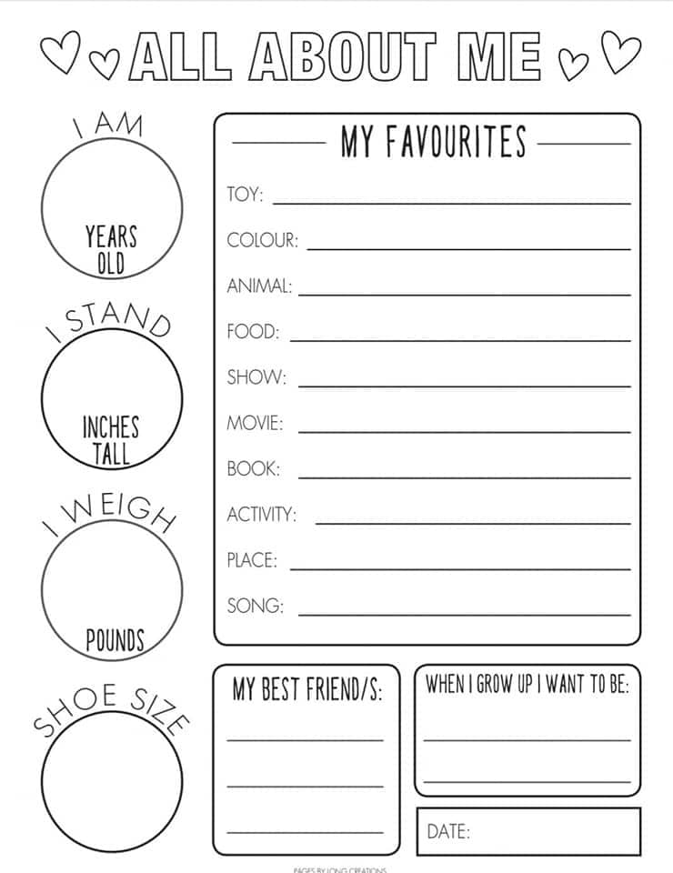

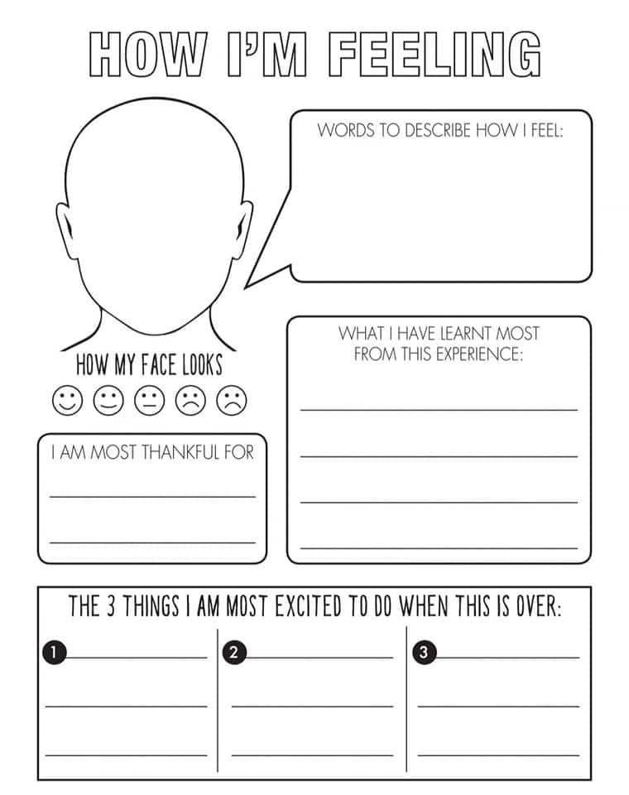
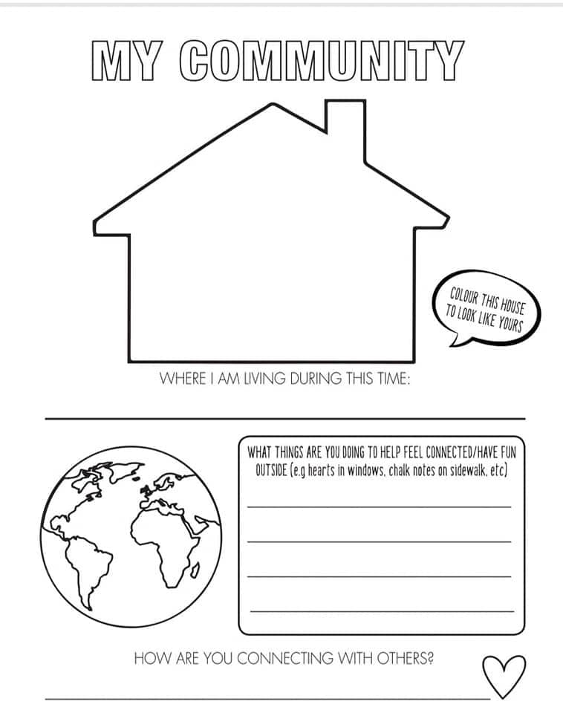

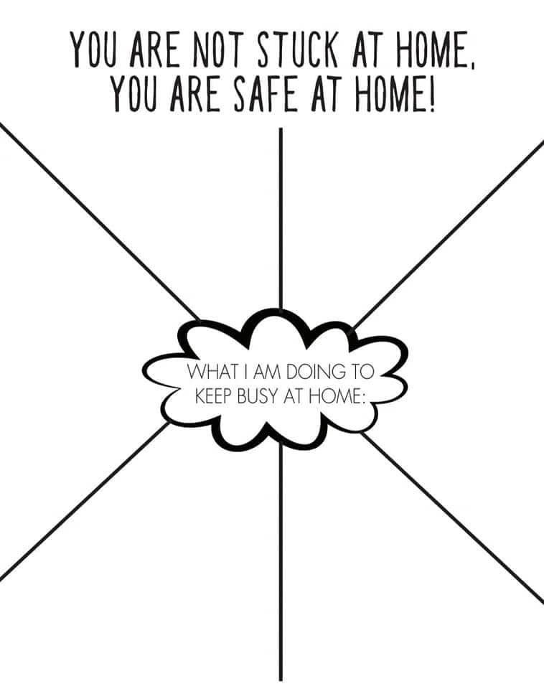

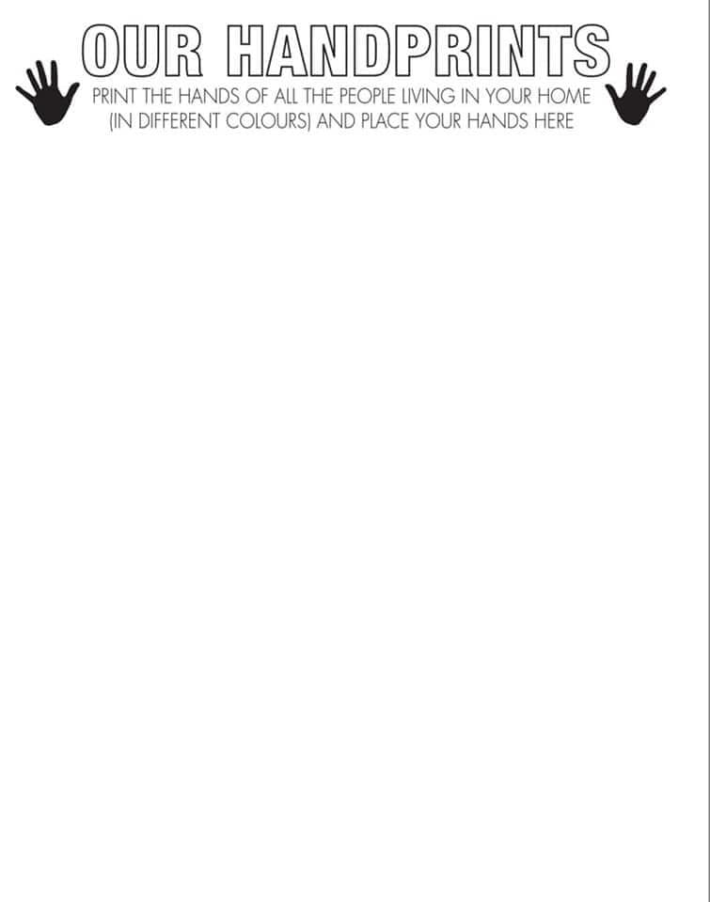

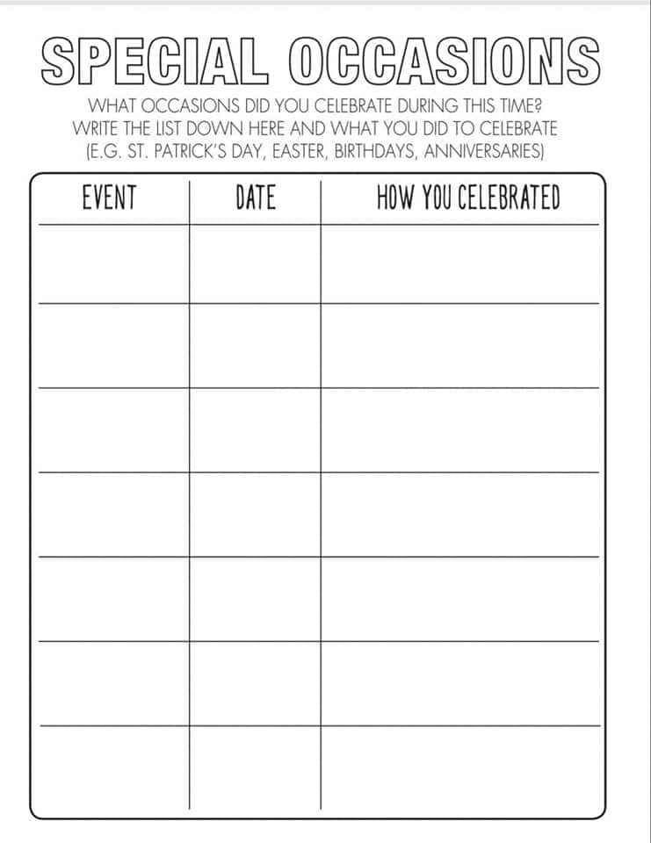

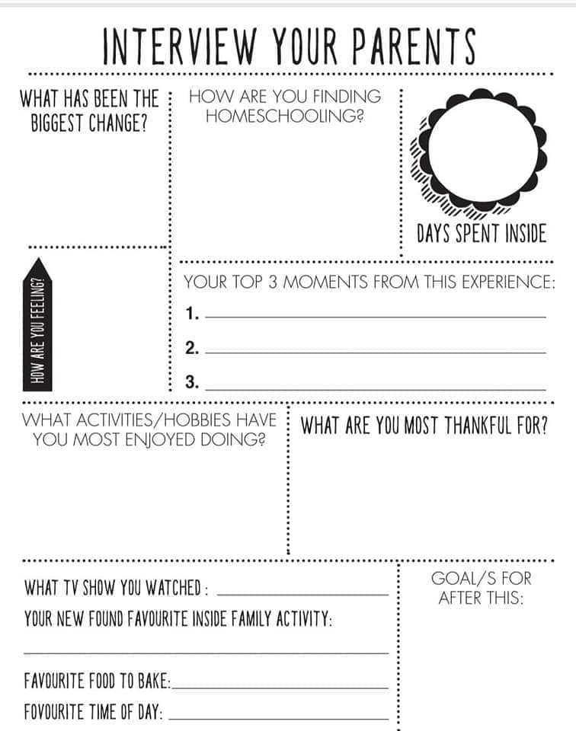

LETTER TO ME FROM MY PARENTS
Date ____________
Dear,
__________________________________________________________________________________________________________________________________________________________________________________________________________________________________________________________________________________________________________________________________________________________________________________________________________________________________________________________________________________________________________________________________________________________________________________________________________________________________________________________________________________________________________________________________________________________________________________________________________________________________________________________________________________________________________________________________________________________________________________________________________________________________________________________________________________________________________________________________________

Love always,
________________________________________

